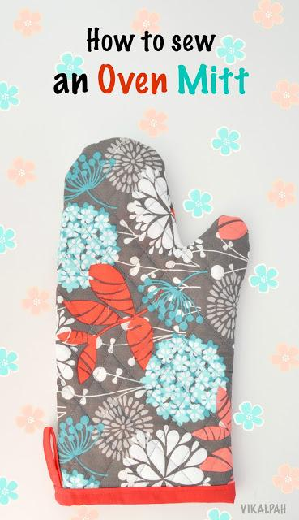

Materials Required :
Printed cotton - fabric quarter
Solid cotton -fabric quarter
Insul bright -
Cotton batting -
Bias tape

Step 1: Using the pattern outline cut the pieces of fabric for making oven mitt. Cut all pieces with your fabric folded so you are cutting 2 at one time. You will need 2 pieces in printed cotton, 2 solid cotton, 2 insult bright and 2 cotton batting.
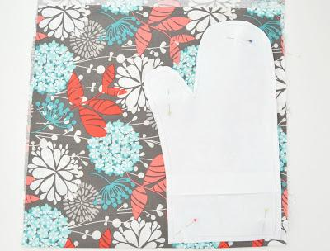

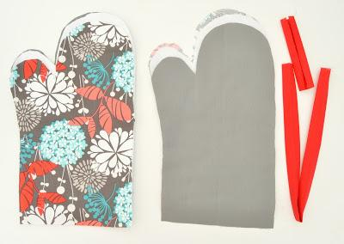

Step 2: Pin all the four layers together (printed cotton, insult bright, cotton batting & solid cotton) in the mentioned order. Using a 5 stitch length stitch around the entire oven mitt using less than ¼ inch seam allowance. Once you have stitched the entire mitt around the edges to hold all of the layers together, you are ready to quilt. Using a ruler or yardstick you will make lines on your oven mitt very LIGHTLY making horizontal lines and then vertical lines. The ultimate aim here is to combine all the layers together. Trim the edges if there is any unevenness.

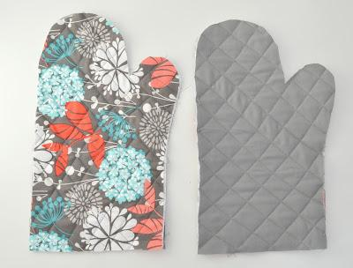

Step 3: With right sides facing each other (Printed cotton sides), make a stitch with 1/4" seam allowance around the entire mit except the bottom where your hand would go.
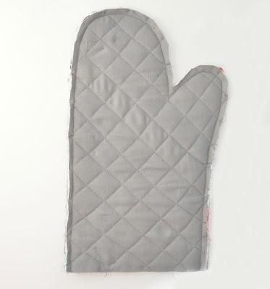
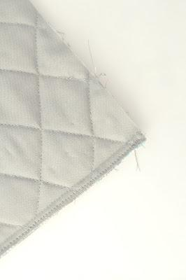

Step 4: Turn inside out. Unfold the bias tape and start aligning the edge of the bias tape to the edge of the oven mitt and pin. Just like the picture below. Leave the remaining binding strip so that it slightly overlaps and cut the excess binding strip. Make a stitch to secure.

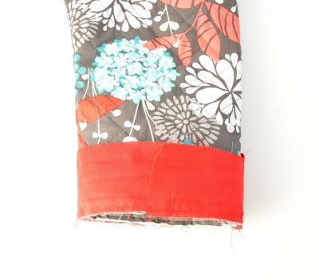

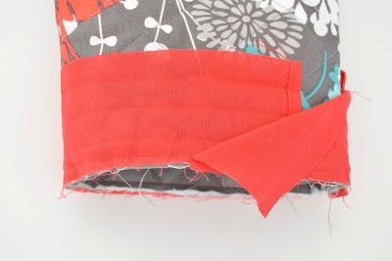

Step 5: Re-Fold the binding strip to cover the edges and stitch to complete the oven mitt.

